Kelcie Feeney

IMD351

12/14/2015

**Work that I have done for others.**

This quarter we were supposed to give ten hours as well as receive ten hours. This report states what hours I have given to various classmates.

**Table Of Work Given.**

|  |  |  |  |  |  |
| --- | --- | --- | --- | --- | --- |
| Date | Name | Hours | Description |  |  |
| 11/24/2015 | Rosanna Lui | 3 | Illustrations for project. | |  |
| 12/1/2015 | Lundy By | 2 | Basics of Photoshop and Illustrator. | | |
| 12/10/2015 | Anthony Do | 3 | Illustrations for project. | |  |
| 12/14/2015 | Lundy By | 2 | logo design |  |  |

11/24/15

3 hours

Rosanna Liu

I spent three hours in total creating these images for Rosanna Liu’s Project. One hour consisted of us brainstorming what could be used in her project. The other two hours were spent actually illustrating these images. Original Illustrator files available upon request.

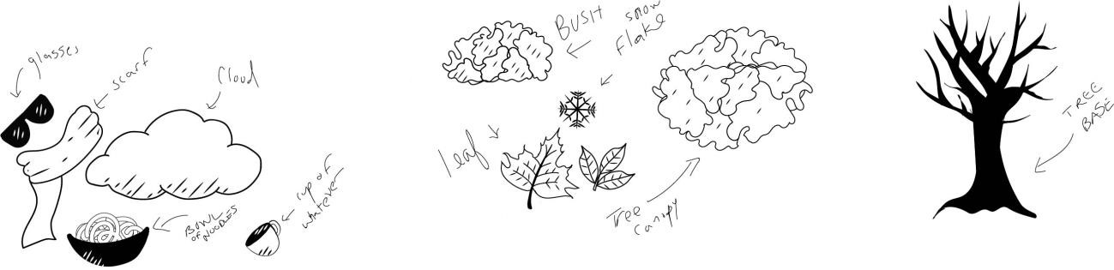

12/01/2015

2 hours

Lundy By

I met with Lundy By for 2 hours on December first. During this time, I taught Lundy about Photoshop layers and how to use them when making a layout. I also showed Lundy how to use Adobe Illustrator to create vector graphics. I showed her the basics of creating and merging shapes as well as how to turn type into a vector shape. Below are the notes that she took during this lesson.

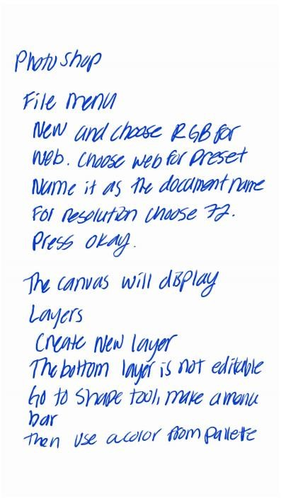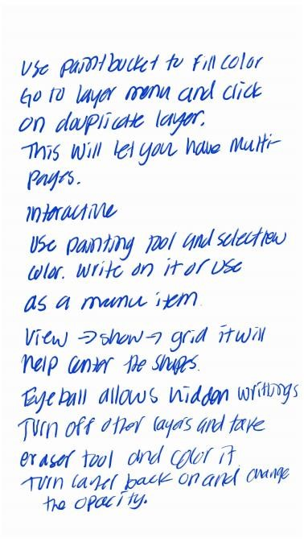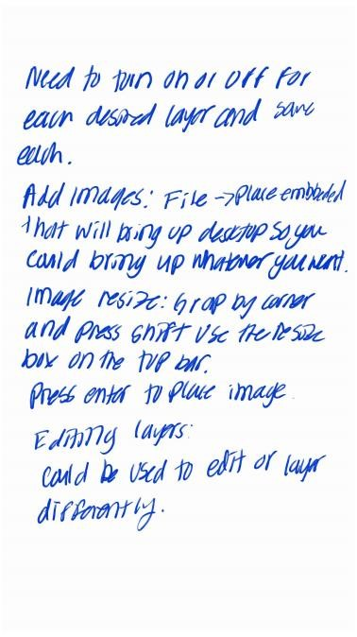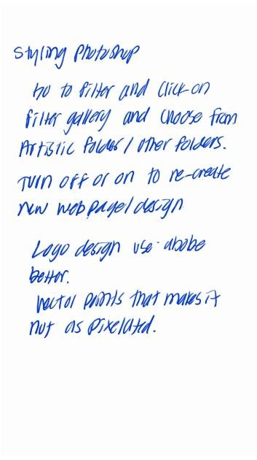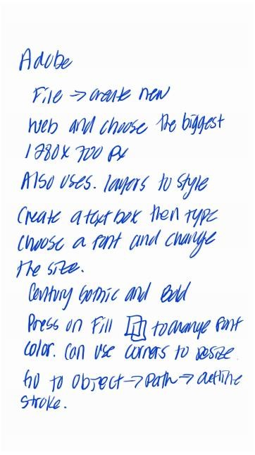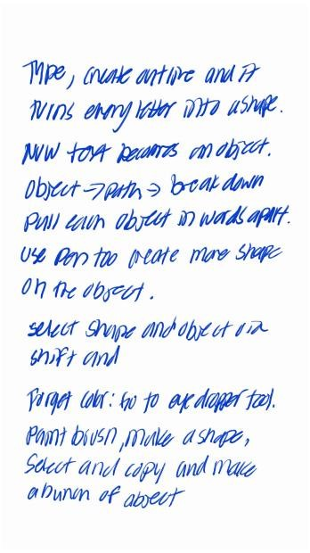

12/10/15

Anthony Do.

3 hours

I created some illustrations to be used in Anthony’s project. These illustrations took me around three hours to create and refine. Original Illustrator files available upon request.

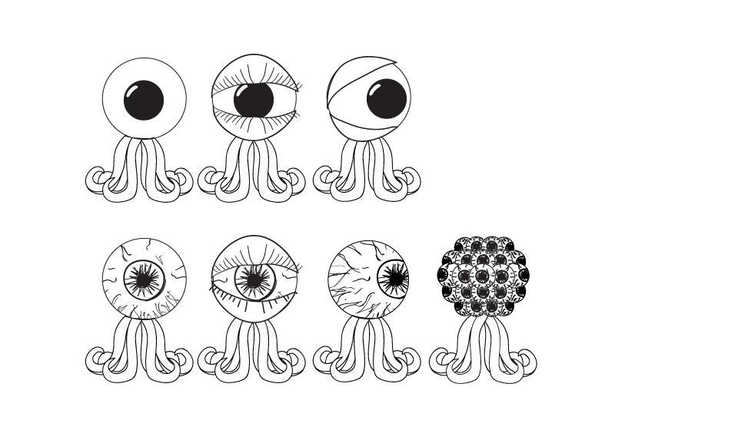

On 12/14/2015

Lundy By 2 hours

I created a selection of logos for Lundy By’s Project. These logos took me around two hours to complete. Original Illustrator files are available upon request.

